Chromium OS Factory Software Platform

几个术语
Releae image:客户使用的image,用于客户出货使用
Recovery image: 可以看作是可用来修复系统问题的release image,它包含release image和FW updater,image中只有它的FW签名是pre-mp/mp的
Factory shim image: a special multi-purpose image that provides:
- Installation from USB. Also known as RMA shim.
- Installation from factory server. Also known as Factory Install shim.
- Reset or cutoff a device after OOBE. Also known as Reset Shim in this case.
Factory toolkit: a self-extraction package that contains a set of python programs, YAML/JSON configuration, and shell scripts that will install itself into /usr/local/factory. This is also considered as the main “factory test program”
Factory bundle: An archive containing everything: a release (recovery) image, test image, factory shim image, factory toolkit, and few setup programs.

典型流程
(1)在装image之前，先把一个FW烧进SPI-ROM（或chromium EC chip）,使主板能启动
(2)主板准备好之后，使用一种imaging方式下载安装toolkit,test image,签名的release image,FW,这时磁 盘上有两种image：test image和shipping image
(3)系统启动时默认使用test image进入并进行测试，这些测试基于pytest文件夹内的脚本
(4)在finalization阶段，test image和test code会被擦除，只剩下release image
(5)若测试项失败，系统可以继续执行下一项测试，并在完成时报告错误（工程模式），可以在某个测试点查看log，在src/platform/factory/py/test/factory.py and generic test lists under src/platform/factory/py/test/test_lists/* 看Options class？？？？？？？
(6)factory test image 和release image 可以合并成一个image再装进设备，进入后是默认使用factory test image

Build factory toolkit
1.进入环境: ~/trunk/src/scripts $
2.export BOARD=strago(设置变量名)
./setup_board --board=${BOARD}(build一个指定的board)
./build_packages(build所有的包,包括autotest)
./build_image test (build一个image,产生一个名为chromiumos_test_image.bin 的image)
./make_factory_toolkit.sh(运行脚本,产生一个install_factory_toolkit.run 文件)
3.产生的image和toolkit放在
~/trunk/src/build/images/YOUR_BOARD_NAME/latest/chromiumos_test_image.bin
~/trunk/src/build/images/YOUR_BOARD_NAME/latest/install_factory_toolkit.run

Build test image

chroot环境下:build_packages --board $BOARD
build_image --board $BOARD test
build完之后拷进U盘的方式:
# inside chroot
cros flash usb:// path/to/chromiumos_test_image.bin
# outside chroot
sudo dd bs=8M if=path/to/image/chromiumos_test_image.bin of=/dev/sdX iflag=fullblock oflag=dsync
或pv -preb 镜像所在路径 | sudo dd of=/dev/sdX bs=8M iflag=fullblock oflag=dsync

Build Factory (Install) Shim
get the factory shim: ./build_packages --board $BOARD
./build_image --board $BOARD factory_install
运行完会提示shim存放的路径，用ls -al 能找到，直接翻文件夹找不到？？？
/mnt/host/source/src/build/images/veyron_jerry/R41-6591.250.2017_08_15_1157-a1(原来/mnt/host/source就是~/factory)
如果想修改shim的配置(一般最关心的是服务器的URL)
在setup文件夹下运行edit_lsb_factory -i path/to/factory_install_shim.bin可对shim的配置作修改，如下：
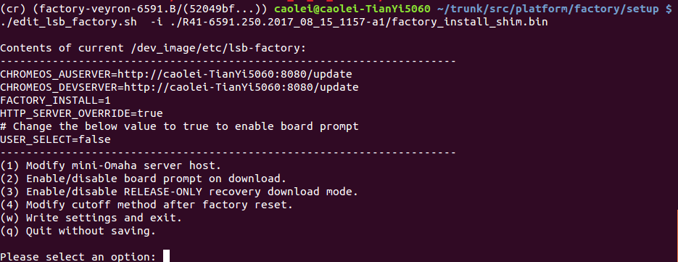

Build factory SDK
进入chroot
Build the SDK documentation: make doc （提示失败？？？）
在浏览器打开：build/doc/index.html
(在factory bundle里有doc的压缩包，直接打开html文件夹查看)
To build HTML documentation, run ``make doc`` in the factory
repository. This will generate HTML documentation in the
``build/doc/html`` directory. A documentation tarball is also
available as ``doc.tar.bz2`` in factory bundles.

imaging methods

RMA和 miniomaha的方式下载镜像都会刷新设备的AP和EC（通过firmwareupdater指定的），如果不指定，安装时会从release image中抽取，因此，如果需要某一特定版本的FW（不是做在Release中的），在make_factory_package.sh运行时添加一个option：--firmware PATH

1.Network Installation(miniomaha)
搭建miniomha：
./setup/make_factory_package.sh \
--board=BOARD \
--test_image=path/to/chromiumos_test_image.bin \
--toolkit=path/to/install_factory_toolkit.run \
--release_image=path/to/chromiumos_image.bin \
--hwid=path/to/hwid_bundle.sh
搭建完后按提示配置和启动，也可以直接运行factorybundle里的脚本start_download_server.sh一步完成配置启动，安装方式有两种：
(1)U盘启动安装
把factory install shim做到U盘，从U盘启动，看到菜单后选择I（nstall）
(2)从netboot firmware启动
先刷image.net.bin,重启后连接omaha即可

2.Pre-Installation (Copy Machine)
为了加快安装image的进程，很多公司会采用pre-flash的方式，使--disk option
./setup/make_factory_package.sh --diskimg=disk_image.bin \
--board=BOARD \
--test_image=path/to/chromiumos_test_image.bin \
--toolkit=path/to/install_factory_toolkit.run \
--release_image=path/to/chromiumos_image.bin \
--hwid=path/to/hwid_bundle.sh

3.USB Installation (RMA)
广泛使用，添加--usbimg option
./make_factory_package.sh --usbimg=usb_image.bin \
--install_shim=下载的factory shim文件路径
--board=BOARD \
--factory_shim=path/to/factory_install_shim.bin \
--test_image=path/to/chromiumos_test_image.bin \
--toolkit=path/to/install_factory_toolkit.run \
--release_image=path/to/chromiumos_image.bin \
--hwid=path/to/hwid_bundle.sh
Flash the usb_image.bin to a USB stick, boot it in with developer switch enabled in recovery mode, and then you will see the installation menu that can install directly from same USB stick without network.

Modifying factory test image or adding test cases
The factory test image runs the series of pytests located at src/platform/factory/py/test/pytests/ (installed in /usr/local/factory/py/test/pytests/ on the DUT). The sequence of pytest cases are determined by test_lists files under /usr/local/factory/py/test/test_lists/. Status is logged to /var/log/factory.log and more details can be found under /var/factory/*
找到要修改的文件，修改完成后push到DUT，主机和DUT必须在同一子网：
进入chroot
./bin/goofy_remote DUT_IP_ADDRESS

如何add test cases？
参考https://storage.googleapis.com/chromeos-factory-docs/sdk/index.html

